

Spring – MVC Framework

Spring MVC Tutorial
- Spring MVC Tutorial
- Example of Spring 3 Web MVC
- Spring 3 MVC Multiple Controller Example
- Spring 3 MVC Login Example
Spring MVC tutorial provides an elegant solution to use MVC in spring framework by the help of DispatcherServlet.
In Spring Web MVC, DispatcherServlet class works as the front controller. It is responsible to manage the flow of the spring mvc application.
The @Controller annotation is used to mark the class as the controller in Spring 3.
The @RequestMapping annotation is used to map the request url. It is applied on the method.

Understanding the flow of Spring Web MVC
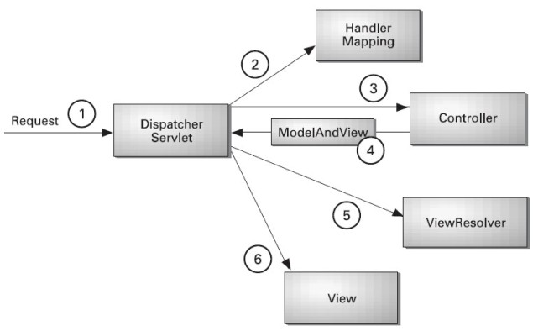
As displayed in the figure, all the incoming request is intercepted by the DispatcherServlet that works as the front controller. The DispatcherServlet gets entry of handler mapping from the xml file and forwards the request to the controller. The controller returns an object of ModelAndView. The DispatcherServlet checks the entry of view resolver in the xml file and invokes the specified view component.

Spring Web MVC Framework Example
Let's see the simple example of spring web MVC framework. There are given 7 steps for creating the spring MVC application. The steps are as follows:
- Create the request page (optional)
- Create the controller class
- Provide the entry of controller in the web.xml file
- Define the bean in the xml file
- Display the message in the JSP page
- Load the spring core and mvc jar files
- Start server and deploy the project

Directory Structure
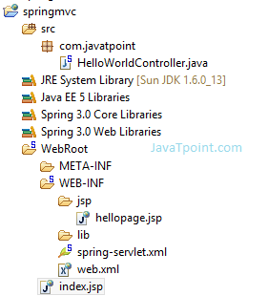

Required Jar files or Maven Dependency
To run this example, you need to load:
- Spring Core jar files
- Spring Web jar files

1) Create the request page (optional)
This is the simple jsp page containing a link. It is optional page. You may direct invoke the action class instead.
index.jsp
<a href="hello.html">click</a>

2) Create the controller class
To create the controller class, we are using two annotations @Controller and @RequestMapping.
The @Controller annotation marks this class as Controller.
The @Requestmapping annotation is used to map the class with the specified name.
This class returns the instance of ModelAndView controller with the mapped name, message name and message value. The message value will be displayed in the jsp page.
HelloWorldController.java
package com.javatpoint;
import org.springframework.stereotype.Controller;
import org.springframework.web.bind.annotation.RequestMapping;
import org.springframework.web.servlet.ModelAndView;
@Controller
public class HelloWorldController {
@RequestMapping("/hello")
public ModelAndView helloWorld() {
String message = "HELLO SPRING MVC HOW R U";
return new ModelAndView("hellopage", "message", message);
}
}

3) Provide the entry of controller in the web.xml file
In this xml file, we are specifying the servlet class DispatcherServlet that acts as the front controller in Spring Web MVC. All the incoming request for the html file will be forwarded to the DispatcherServlet.
web.xml
<?xml version="1.0" encoding="UTF-8"?>
<web-app version="2.5"
xmlns="http://java.sun.com/xml/ns/javaee"
xmlns:xsi="http://www.w3.org/2001/XMLSchema-instance"
xsi:schemaLocation="http://java.sun.com/xml/ns/javaee
http://java.sun.com/xml/ns/javaee/web-app_2_5.xsd">
<servlet>
<servlet-name>spring</servlet-name>
<servlet-class>org.springframework.web.servlet.DispatcherServlet</servlet-class>
<load-on-startup>1</load-on-startup>
</servlet>
<servlet-mapping>
<servlet-name>spring</servlet-name>
<url-pattern>*.html</url-pattern>
</servlet-mapping>
</web-app>

4) Define the bean in the xml file
This is the important configuration file where we need to specify the ViewResolver and View components.
The context:component-scan element defines the base-package where DispatcherServlet will search the controller class.
Here, the InternalResourceViewResolver class is used for the ViewResolver.
The prefix+string returned by controller+suffix page will be invoked for the view component.
This xml file should be located inside the WEB-INF directory.
spring-servlet.xml
<?xml version="1.0" encoding="UTF-8"?>
<beans xmlns="http://www.springframework.org/schema/beans"
xmlns:xsi="http://www.w3.org/2001/XMLSchema-instance"
xmlns:p="http://www.springframework.org/schema/p"
xmlns:context="http://www.springframework.org/schema/context"
xsi:schemaLocation="http://www.springframework.org/schema/beans
http://www.springframework.org/schema/beans/spring-beans-3.0.xsd
http://www.springframework.org/schema/context
http://www.springframework.org/schema/context/spring-context-3.0.xsd">
<context:component-scan base-package="com.javatpoint" />
<bean class="org.springframework.web.servlet.view.InternalResourceViewResolver">
<property name="prefix" value="/WEB-INF/jsp/" />
<property name="suffix" value=".jsp" />
</bean>
</beans>

5) Display the message in the JSP page
This is the simple JSP page, displaying the message returned by the Controller.
It must be located inside the WEB-INF/jsp directory for this example only.
hellopage.jsp
Message is: ${message}

Output
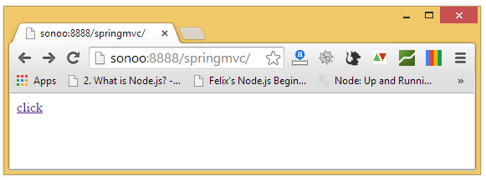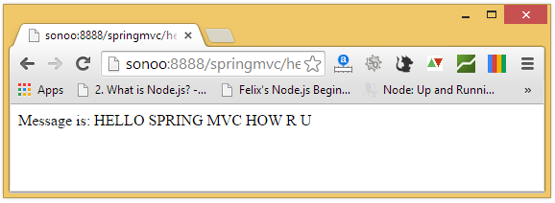

Download spring MVC example
We have created this application in MyEclipse IDE which already provides the jar files. If you use eclipse or other IDE's, you need to load the jar file for spring MVC.

Spring 3 MVC Multiple Controller Example
We can have a lot of controller classes in Spring Framework. In this example, we are creating two Controller classes HelloWorldController and WelcomeWorldController.

1) Controller Classes
HelloWorldController.java
package com.javatpoint;
import org.springframework.stereotype.Controller;
import org.springframework.web.bind.annotation.RequestMapping;
import org.springframework.web.servlet.ModelAndView;

@Controller
public class HelloWorldController {

@RequestMapping("/hello")
public ModelAndView helloWorld() {
String message = "HELLO SPRING MVC";
return new ModelAndView("hellopage", "message", message);
}
}

WelcomeWorldController.java
package com.javatpoint;
import org.springframework.stereotype.Controller;
import org.springframework.web.bind.annotation.RequestMapping;
import org.springframework.web.servlet.ModelAndView;

@Controller
public class WelcomeWorldController {

@RequestMapping("/welcome")
public ModelAndView helloWorld() {

String message = "WELCOME SPRING MVC";
return new ModelAndView("welcomepage", "message", message);
}
}

2) View components
To run this example, It must be located inside the WEB-INF/jsp directory.
hellopage.jsp
Message is: ${message}
welcomepage.jsp
Message is: ${message}

3) Index page
It is the optional welcome page, that provide the links to invoke both controller.
index.jsp
<a href="hello.html">click</a>|
<a href="welcome.html">click</a>

Spring MVC Request Response Example
We can simply create login application by following the Spring MVC. We need to pass HttpServletRequest and HttpServletResponse objects in the request processing method of the Controller class. Let's see the example:

1) Controller Class
HelloWorldController.java
package com.javatpoint;
import javax.servlet.http.HttpServletRequest;
import javax.servlet.http.HttpServletResponse;
import org.springframework.stereotype.Controller;
import org.springframework.web.bind.annotation.RequestMapping;
import org.springframework.web.servlet.ModelAndView;

@Controller
public class HelloWorldController {

@RequestMapping("/hello")
public ModelAndView helloWorld(HttpServletRequest request,HttpServletResponse res) {
String name=request.getParameter("name");
String password=request.getParameter("password");

if(password.equals("admin")){
String message = "HELLO "+name;
return new ModelAndView("hellopage", "message", message);
}
else{
return new ModelAndView("errorpage", "message","Sorry, username or password error"); }
}
}

2) View components
To run this example, It must be located inside the WEB-INF/jsp directory.
hellopage.jsp
Message is: ${message}
errorpage.jsp
${message}
<jsp:include page="/index.jsp"></jsp:include>

3) Index page
It is the login page, that recieve name and password from the user.
index.jsp
<form action="hello.html" method="post">
Name:<input type="text" name="name"/><br/>
Password:<input type="password" name="password"/><br/>
<input type="submit" value="login"/>
</form>

Spring MVC Form Handling Example
By the help of form handling, we will be able to create CRUD application using Spring MVC.
Here, we will learn how to handle a form data in spring MVC without using database. Here, we will use @Controler, @RequestMapping and @ModelAttribute annotations.
To display the input form, we are going to use <form:form> tag of spring framework. Let's see a simple example to store form data in a model object and display data of a list.

index.jsp
<a href="empform">Add Employee</a>
<a href="viewemp">View Employees</a>

Emp.java
package com.javatpoint.beans;
public class Emp {
private int id;
private String name;
private float salary;
private String designation;

public Emp() {}

public Emp(int id, String name, float salary, String designation) {
super();
this.id = id;
this.name = name;
this.salary = salary;
this.designation = designation;
}
public int getId() {
return id;
}
public void setId(int id) {
this.id = id;
}
public String getName() {
return name;
}
public void setName(String name) {
this.name = name;
}
public float getSalary() {
return salary;
}
public void setSalary(float salary) {
this.salary = salary;
}
public String getDesignation() {
return designation;
}
public void setDesignation(String designation) {
this.designation = designation;
}
}

EmpController.java
package com.javatpoint.controllers;

import java.util.ArrayList;
import java.util.List;
import org.springframework.stereotype.Controller;
import org.springframework.web.bind.annotation.ModelAttribute;
import org.springframework.web.bind.annotation.RequestMapping;
import org.springframework.web.bind.annotation.RequestMethod;
import org.springframework.web.servlet.ModelAndView;
import com.javatpoint.beans.Emp;
@Controller
public class EmpController {

@RequestMapping("/empform")
public ModelAndView showform(){
//command is a reserved request attribute name, now use <form> tag to show object data
return new ModelAndView("empform","command",new Emp());
}
@RequestMapping(value="/save",method = RequestMethod.POST)
public ModelAndView save(@ModelAttribute("emp") Emp emp){
//write code to save emp object
//here, we are displaying emp object to prove emp has data
System.out.println(emp.getName()+" "+emp.getSalary()+" "+emp.getDesignation()) ;
//return new ModelAndView("empform","command",emp);//will display object data
return new ModelAndView("redirect:/viewemp");
//will redirect to viewemp request mapping
}

@RequestMapping("/viewemp")
public ModelAndView viewemp(){
//write the code to get all employees from DAO
//here, we are writing manual code of list for easy understanding
List<Emp> list=new ArrayList<Emp>();
list.add(new Emp(1,"rahul",35000f,"S.Engineer"));
list.add(new Emp(2,"aditya",25000f,"IT Manager"));
list.add(new Emp(3,"sachin",55000f,"Care Taker"));
return new ModelAndView("viewemp","list",list);
}
}

web.xml
<?xml version="1.0" encoding="UTF-8"?>
<web-app version="2.5"
xmlns="http://java.sun.com/xml/ns/javaee"
xmlns:xsi="http://www.w3.org/2001/XMLSchema-instance"
xsi:schemaLocation="http://java.sun.com/xml/ns/javaee
http://java.sun.com/xml/ns/javaee/web-app_2_5.xsd">
<servlet>
<servlet-name>spring</servlet-name>
<servlet-class>org.springframework.web.servlet.DispatcherServlet</servlet-class>
<load-on-startup>1</load-on-startup>
</servlet>
<servlet-mapping>
<servlet-name>spring</servlet-name>
<url-pattern>/</url-pattern>
</servlet-mapping>
</web-app>
spring-servlet.xml
<?xml version="1.0" encoding="UTF-8"?>
<beans xmlns="http://www.springframework.org/schema/beans"
xmlns:xsi="http://www.w3.org/2001/XMLSchema-instance"
xmlns:p="http://www.springframework.org/schema/p"
xmlns:context="http://www.springframework.org/schema/context"
xsi:schemaLocation="http://www.springframework.org/schema/beans
http://www.springframework.org/schema/beans/spring-beans-3.0.xsd
http://www.springframework.org/schema/context
http://www.springframework.org/schema/context/spring-context-3.0.xsd">

<context:component-scan base package="com.javatpoint.controllers"></context:component-scan>
<bean class="org.springframework.web.servlet.view.InternalResourceViewResolver">
<property name="prefix" value="/WEB-INF/jsp/"></property>
<property name="suffix" value=".jsp"></property>
</bean>
</beans>

empform.jsp
<%@ taglib uri="http://www.springframework.org/tags/form" prefix="form"%>
<%@ taglib uri="http://java.sun.com/jsp/jstl/core" prefix="c"%>

<form:form method="post" action="save">
<table >
<tr>
<td>Name : </td>
<td><form:input path="name" /></td>
</tr>
<tr>
<td>Salary :</td>
<td><form:input path="salary" /></td>
</tr>
<tr>
<td>Designation :</td>
<td><form:input path="designation" /></td>
</tr>
<tr>
<td colspan="2"><input type="submit" value="Save" /></td>
</tr>
</table>
</form:form>
viewemp.jsp
<%@ taglib uri="http://www.springframework.org/tags/form" prefix="form"%>
<%@ taglib uri="http://java.sun.com/jsp/jstl/core" prefix="c"%>

<table border="2" width="70%" cellpadding="2">
<tr><th>Id</th><th>Name</th><th>Salary</th><th>Designation</th></tr>
<c:forEach var="emp" items="${list}">
<tr>
<td>${emp.id}</td>
<td>${emp.name}</td>
<td>${emp.salary}</td>
<td>${emp.designation}</td>
</tr>
</c:forEach>
</table>

Output
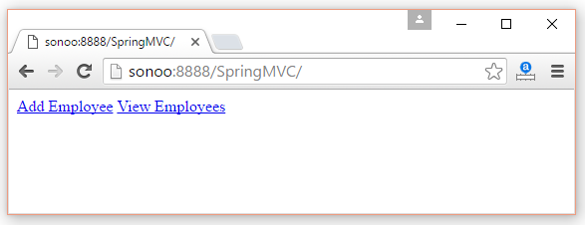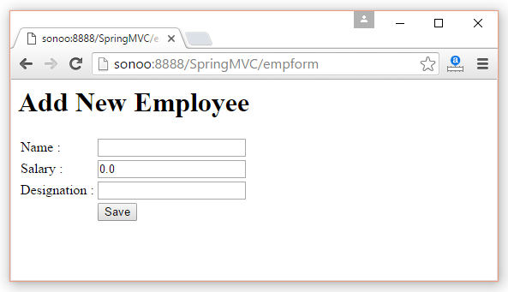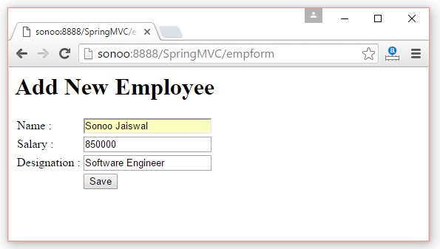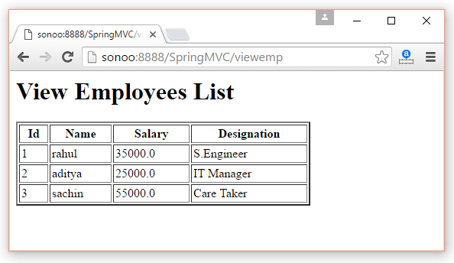

Spring MVC CRUD Example

By the help of form handling and JdbcTemplate, we will be able to create CRUD application using Spring MVC.

Create table
Here, we are using emp99 table of oracle 10g database which has 4 fields: id, name, salary and designation. Here, id is auto incremented which is generated by sequence.
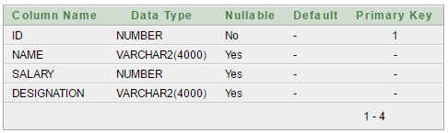

Spring MVC CRUD Example
index.jsp
<a href="empform">Add Employee</a>
<a href="viewemp">View Employees</a>

Emp.java
package com.javatpoint.beans;

public class Emp {
private int id;
private String name;
private float salary;
private String designation;

public int getId() {
return id;
}
public void setId(int id) {
this.id = id;
}
public String getName() {
return name;
}
public void setName(String name) {
this.name = name;
}
public float getSalary() {
return salary;
}
public void setSalary(float salary) {
this.salary = salary;
}
public String getDesignation() {
return designation;
}
public void setDesignation(String designation) {
this.designation = designation;
}

} EmpDao.java
package com.javatpoint.dao;
import java.sql.ResultSet;
import java.sql.SQLException;
import java.util.List;
import org.springframework.jdbc.core.BeanPropertyRowMapper;
import org.springframework.jdbc.core.JdbcTemplate;
import org.springframework.jdbc.core.RowMapper;
import com.javatpoint.beans.Emp;

public class EmpDao {
JdbcTemplate template;

public void setTemplate(JdbcTemplate template) {
this.template = template;
}
public int save(Emp p){
String sql="insert into Emp99(name,salary,designation)
values('"+p.getName()+"',"+p.getSalary()+",'"+p.getDesignation()+"')";
return template.update(sql);
}
public int update(Emp p){
String sql="update Emp99 set name='"+p.getName()+"', salary="+p.getSalary()+",
designation='"+p.getDesignation()+"' where id="+p.getId()+"";
return template.update(sql);
}
public int delete(int id){
String sql="delete from Emp99 where id="+id+"";
return template.update(sql);
}
public Emp getEmpById(int id){
String sql="select * from Emp99 where id=?";
return template.queryForObject(sql, new Object[]{id},new BeanPropertyRowMapper<Emp>(Emp.class));
}
public List<Emp> getEmployees(){
return template.query("select * from Emp99",new RowMapper<Emp>(){
public Emp mapRow(ResultSet rs, int row) throws SQLException {
Emp e=new Emp();
e.setId(rs.getInt(1));
e.setName(rs.getString(2));
e.setSalary(rs.getFloat(3));
e.setDesignation(rs.getString(4));
return e;
}
});
}
}

EmpController.java
package com.javatpoint.controllers;
import java.util.ArrayList;
import java.util.List;
import org.springframework.beans.factory.annotation.Autowired;
import org.springframework.stereotype.Controller;
import org.springframework.web.bind.annotation.ModelAttribute;
import org.springframework.web.bind.annotation.PathVariable;
import org.springframework.web.bind.annotation.RequestMapping;
import org.springframework.web.bind.annotation.RequestMethod;
import org.springframework.web.servlet.ModelAndView;
import com.javatpoint.beans.Emp;
import com.javatpoint.dao.EmpDao;
@Controller
public class EmpController {
@Autowired
EmpDao dao;//will inject dao from xml file

/*It displays a form to input data, here "command" is a reserved request attribute
*which is used to display object data into form
*/
@RequestMapping("/empform")
public ModelAndView showform(){
return new ModelAndView("empform","command",new Emp());
}
/*It saves object into database. The @ModelAttribute puts request data
* into model object. You need to mention RequestMethod.POST method
* because default request is GET*/
@RequestMapping(value="/save",method = RequestMethod.POST)
public ModelAndView save(@ModelAttribute("emp") Emp emp){
dao.save(emp);
return new ModelAndView("redirect:/viewemp");//will redirect to viewemp request mapping
}
/* It provides list of employees in model object */
@RequestMapping("/viewemp")
public ModelAndView viewemp(){
List<Emp> list=dao.getEmployees();
return new ModelAndView("viewemp","list",list);
}
/* It displays object data into form for the given id.
* The @PathVariable puts URL data into variable.*/
@RequestMapping(value="/editemp/{id}")
public ModelAndView edit(@PathVariable int id){
Emp emp=dao.getEmpById(id);
return new ModelAndView("empeditform","command",emp);
}
/* It updates model object. */
@RequestMapping(value="/editsave",method = RequestMethod.POST)
public ModelAndView editsave(@ModelAttribute("emp") Emp emp){
dao.update(emp);
return new ModelAndView("redirect:/viewemp");
}
/* It deletes record for the given id in URL and redirects to /viewemp */
@RequestMapping(value="/deleteemp/{id}",method = RequestMethod.GET)
public ModelAndView delete(@PathVariable int id){
dao.delete(id);
return new ModelAndView("redirect:/viewemp");
}

}

web.xml
<?xml version="1.0" encoding="UTF-8"?>
<web-app version="2.5"
xmlns="http://java.sun.com/xml/ns/javaee"
xmlns:xsi="http://www.w3.org/2001/XMLSchema-instance"
xsi:schemaLocation="http://java.sun.com/xml/ns/javaee
http://java.sun.com/xml/ns/javaee/web-app_2_5.xsd">
<servlet>
<servlet-name>spring</servlet-name>
<servlet-class>org.springframework.web.servlet.DispatcherServlet</servlet-class>
<load-on-startup>1</load-on-startup>
</servlet>
<servlet-mapping>
<servlet-name>spring</servlet-name>
<url-pattern>/</url-pattern>
</servlet-mapping>
</web-app>
spring-servlet.xml
<?xml version="1.0" encoding="UTF-8"?>
<beans xmlns="http://www.springframework.org/schema/beans"
xmlns:xsi="http://www.w3.org/2001/XMLSchema-instance"
xmlns:p="http://www.springframework.org/schema/p"
xmlns:context="http://www.springframework.org/schema/context"
xsi:schemaLocation="http://www.springframework.org/schema/beans
http://www.springframework.org/schema/beans/spring-beans-3.0.xsd
http://www.springframework.org/schema/context
http://www.springframework.org/schema/context/spring-context-3.0.xsd">

<context:component-scan base package="com.javatpoint.controllers"></context:component-scan>

<bean class="org.springframework.web.servlet.view.InternalResourceViewResolver">
<property name="prefix" value="/WEB-INF/jsp/"></property>
<property name="suffix" value=".jsp"></property>
</bean>

<bean id="ds" class="org.springframework.jdbc.datasource.DriverManagerDataSource">
<property name="driverClassName" value="oracle.jdbc.driver.OracleDriver"></property>
<property name="url" value="jdbc:oracle:thin:@localhost:1521:xe"></property>
<property name="username" value="system"></property>
<property name="password" value="oracle"></property>
</bean>

<bean id="jt" class="org.springframework.jdbc.core.JdbcTemplate">
<property name="dataSource" ref="ds"></property>
</bean>

<bean id="dao" class="com.javatpoint.dao.EmpDao">
<property name="template" ref="jt"></property>
</bean>
</beans> empform.jsp
<%@ taglib uri="http://www.springframework.org/tags/form" prefix="form"%>
<%@ taglib uri="http://java.sun.com/jsp/jstl/core" prefix="c"%>

<h1>Add New Employee</h1>
<form:form method="post" action="save">
<table >
<tr>
<td>Name : </td>
<td><form:input path="name" /></td>
</tr>
<tr>
<td>Salary :</td>
<td><form:input path="salary" /></td>
</tr>
<tr>
<td>Designation :</td>
<td><form:input path="designation" /></td>
</tr>
<tr>
<td> </td>
<td><input type="submit" value="Save" /></td>
</tr>
</table>
</form:form> empeditform.jsp
Here "/SpringMVCCRUDSimple" is the project name, change this if you have different project name. For live application, you can provide full URL.
<%@ taglib uri="http://www.springframework.org/tags/form" prefix="form"%>
<%@ taglib uri="http://java.sun.com/jsp/jstl/core" prefix="c"%>

<h1>Edit Employee</h1>
<form:form method="POST" action="/SpringMVCCRUDSimple/editsave">
<table >
<tr>
<td></td>
<td><form:hidden path="id" /></td>
</tr>
<tr>
<td>Name : </td>
<td><form:input path="name" /></td>
</tr>
<tr>
<td>Salary :</td>
<td><form:input path="salary" /></td>
</tr>
<tr>
<td>Designation :</td>
<td><form:input path="designation" /></td>
</tr>

<tr>
<td> </td>
<td><input type="submit" value="Edit Save" /></td>
</tr>
</table>
</form:form> viewemp.jsp
<%@ taglib uri="http://www.springframework.org/tags/form" prefix="form"%>
<%@ taglib uri="http://java.sun.com/jsp/jstl/core" prefix="c"%>

<h1>Employees List</h1>
<table border="2" width="70%" cellpadding="2">
<tr><th>Id</th><th>Name</th><th>Salary</th><th>Designation</th><th>Edit</th> <th>Delete</th></tr>
<c:forEach var="emp" items="${list}">
<tr>
<td>${emp.id}</td>
<td>${emp.name}</td>
<td>${emp.salary}</td>
<td>${emp.designation}</td>
<td><a href="editemp/${emp.id}">Edit</a></td>
<td><a href="deleteemp/${emp.id}">Delete</a></td>
</tr>
</c:forEach>
</table>
<br/>
<a href="empform">Add New Employee</a> Output
Click on "Add New Employee" link, you will see following form.
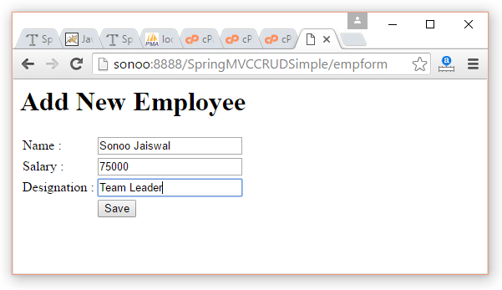
Fill data and click on save button. You will see employees list.
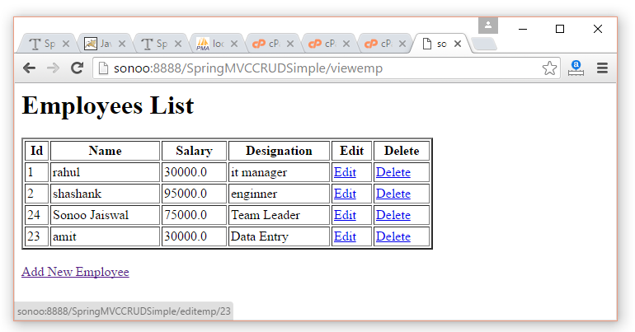
Now click on "edit" link, a form will appear with the data.
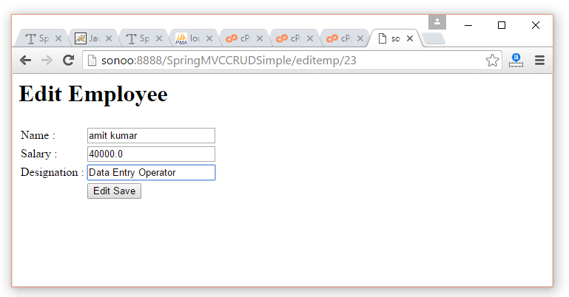
Now change the data of the form and click on "edit save" button.
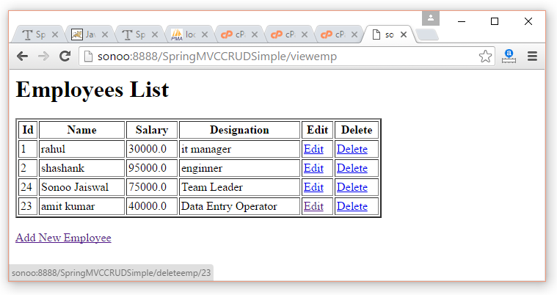
Now click on "delete" link, you will see employees list with deleted record.
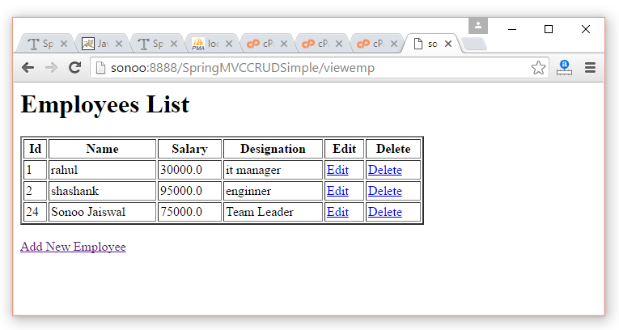

Spring MVC Pagination Example
Pagination is used to display large number of records in different parts. In such case, we display 10, 20 or 50 records in one page. For remaining records, we provide links.
We can simply create pagination example in Spring MVC. In this pagination example, we are using MySQL database to fetch records.

Create table or import sql file
Here, we have created "emp" table in "test" database. The emp table has three fields: id, name and salary. Either create table and insert records manually or import our sql file.

Spring MVC Pagination Example
index.jsp
<a href="viewemp/1">View Employees</a> Emp.java
package com.javatpoint.beans;

public class Emp {
private int id;
private String name;
private float salary;

public int getId() {
return id;
}
public void setId(int id) {
this.id = id;
}
public String getName() {
return name;
}
public void setName(String name) {
this.name = name;
}
public float getSalary() {
return salary;
}
public void setSalary(float salary) {
this.salary = salary;
}

}
EmpDao.java
package com.javatpoint.dao;

import java.sql.ResultSet;
import java.sql.SQLException;
import java.util.List;
import org.springframework.jdbc.core.JdbcTemplate;
import org.springframework.jdbc.core.RowMapper;
import com.javatpoint.beans.Emp;

public class EmpDao {
JdbcTemplate template;

public void setTemplate(JdbcTemplate template) {
this.template = template;
}
public List<Emp> getEmployeesByPage(int pageid,int total){
String sql="select * from Emp limit "+(pageid-1)+","+total;
return template.query(sql,new RowMapper<Emp>(){
public Emp mapRow(ResultSet rs, int row) throws SQLException {
Emp e=new Emp();
e.setId(rs.getInt(1));
e.setName(rs.getString(2));
e.setSalary(rs.getFloat(3));
return e;
}
});
}
} EmpController.java
package com.javatpoint.controllers;

import java.util.ArrayList;
import java.util.List;

import org.springframework.beans.factory.annotation.Autowired;
import org.springframework.stereotype.Controller;
import org.springframework.web.bind.annotation.ModelAttribute;
import org.springframework.web.bind.annotation.PathVariable;
import org.springframework.web.bind.annotation.RequestMapping;
import org.springframework.web.bind.annotation.RequestMethod;
import org.springframework.web.servlet.ModelAndView;
import com.javatpoint.beans.Emp;
import com.javatpoint.dao.EmpDao;
@Controller
public class EmpController {
@Autowired
EmpDao dao;

@RequestMapping(value="/viewemp/{pageid}")
public ModelAndView edit(@PathVariable int pageid){
int total=5;
if(pageid==1){}
else{
pageid=(pageid-1)*total+1;
}
List<Emp> list=dao.getEmployeesByPage(pageid,total);

return new ModelAndView("viewemp","list",list);
}

} web.xml
<?xml version="1.0" encoding="UTF-8"?>
<web-app version="2.5"
xmlns="http://java.sun.com/xml/ns/javaee"
xmlns:xsi="http://www.w3.org/2001/XMLSchema-instance"
xsi:schemaLocation="http://java.sun.com/xml/ns/javaee
http://java.sun.com/xml/ns/javaee/web-app_2_5.xsd">
<servlet>
<servlet-name>spring</servlet-name>
<servlet-class>org.springframework.web.servlet.DispatcherServlet</servlet-class>
<load-on-startup>1</load-on-startup>
</servlet>
<servlet-mapping>
<servlet-name>spring</servlet-name>
<url-pattern>/</url-pattern>
</servlet-mapping>
</web-app>
spring-servlet.xml
<?xml version="1.0" encoding="UTF-8"?>
<beans xmlns="http://www.springframework.org/schema/beans"
xmlns:xsi="http://www.w3.org/2001/XMLSchema-instance"
xmlns:p="http://www.springframework.org/schema/p"
xmlns:context="http://www.springframework.org/schema/context"
xsi:schemaLocation="http://www.springframework.org/schema/beans
http://www.springframework.org/schema/beans/spring-beans-3.0.xsd
http://www.springframework.org/schema/context
http://www.springframework.org/schema/context/spring-context-3.0.xsd">

<context:component-scan base
package="com.javatpoint.controllers"></context:component-scan>
<bean class="org.springframework.web.servlet.view.InternalResourceViewResolver">
<property name="prefix" value="/WEB-INF/jsp/"></property>
<property name="suffix" value=".jsp"></property>
</bean>

<bean id="ds" class="org.springframework.jdbc.datasource.DriverManagerDataSource">
<property name="driverClassName" value="com.mysql.jdbc.Driver"></property>
<property name="url" value="jdbc:mysql://localhost:3306/test"></property>
<property name="username" value=""></property>
<property name="password" value=""></property>
</bean>

<bean id="jt" class="org.springframework.jdbc.core.JdbcTemplate">
<property name="dataSource" ref="ds"></property>
</bean>

<bean id="dao" class="com.javatpoint.dao.EmpDao">
<property name="template" ref="jt"></property>
</bean>
</beans> viewemp.jsp
<%@ taglib uri="http://java.sun.com/jsp/jstl/core" prefix="c"%>
<h1>Employees List</h1>
<table border="2" width="70%" cellpadding="2">
<tr><th>Id</th><th>Name</th><th>Salary</th></tr>
<c:forEach var="emp" items="${list}">
<tr>
<td>${emp.id}</td>
<td>${emp.name}</td>
<td>${emp.salary}</td>
</tr>
</c:forEach>
</table>
<br/>
<a href="/SpringMVC/viewemp/1">1</a>
<a href="/SpringMVC/viewemp/2">2</a>
<a href="/SpringMVC/viewemp/3">3</a> Output
